**Invoice Doc Types:** The Invoice Doc Types tab holds the list of all eligible CNH invoice document types available for use in invoicing orders.

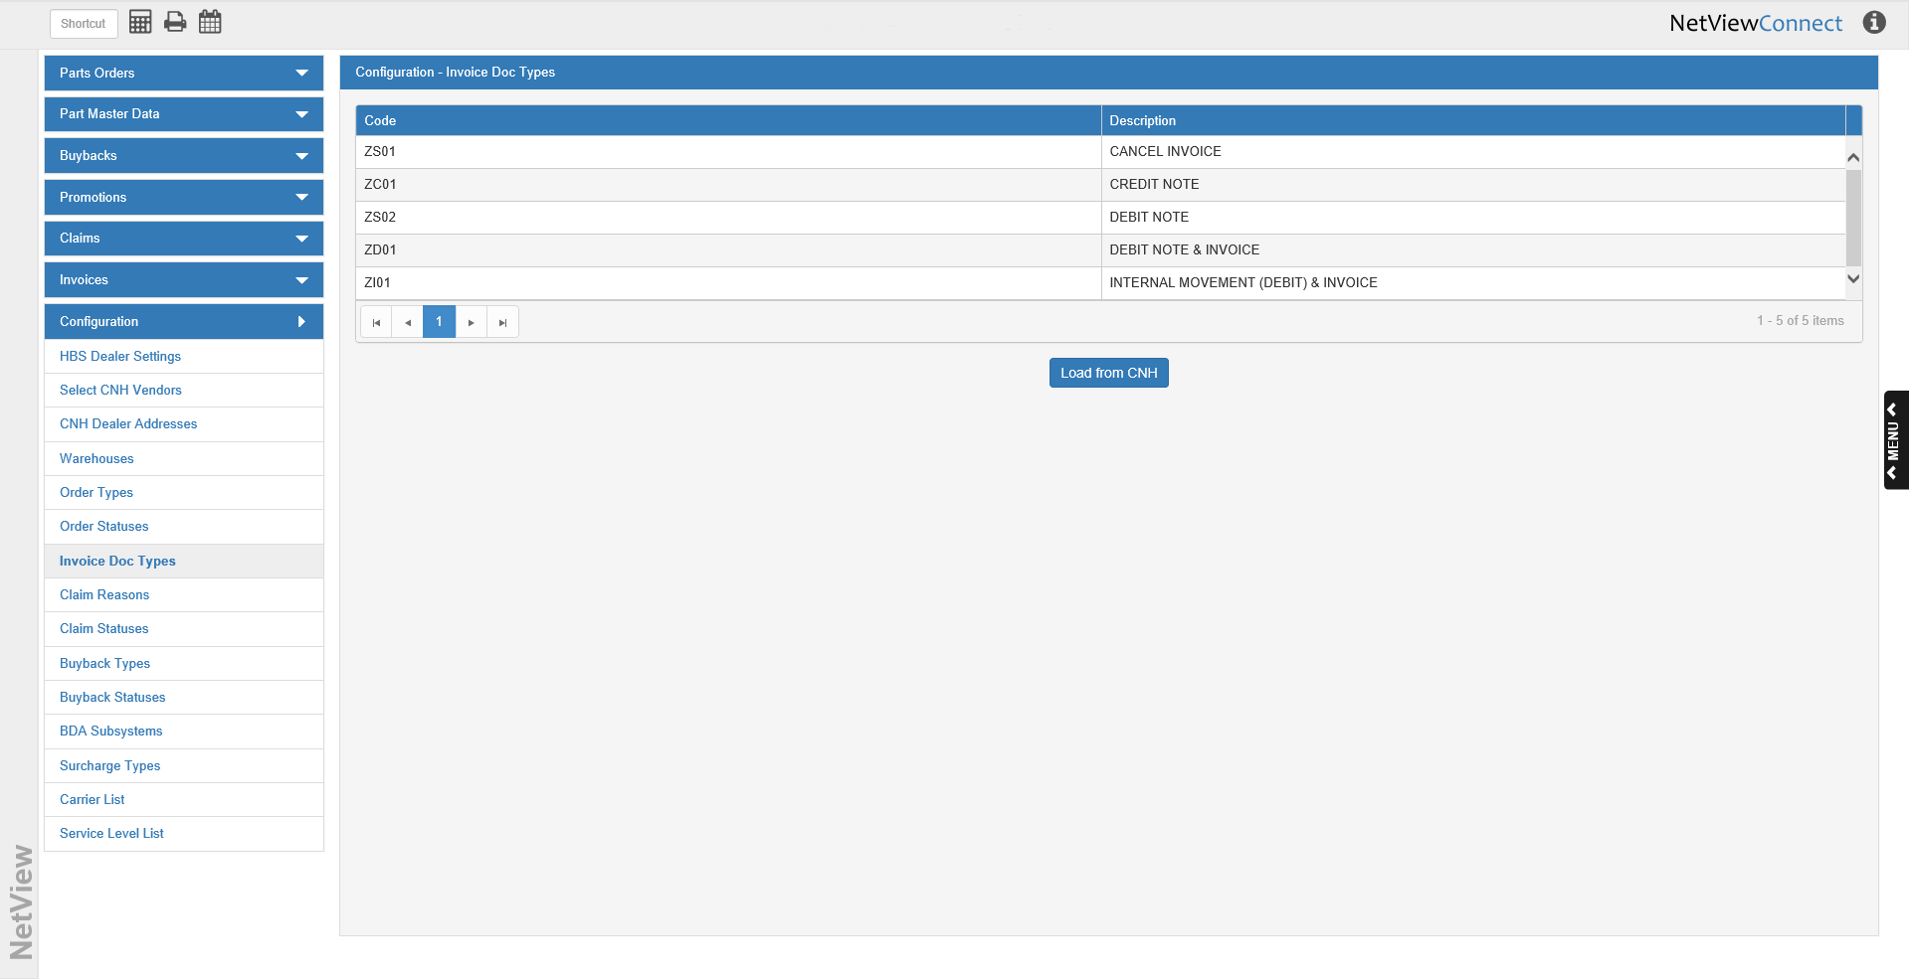

**Code:** This column holds the CNH Invoice Doc Type Code.

**Description:** This column holds the description of the document type (credit, debit, etc.).

**Load from CNH:** When you first open CNH Connect (CSPS), you will need to click this button to load the invoice doc type list from CNH, or you will not have access to the document types when working with invoices. After the button’s first use, the program will automatically reload the list every 30 days, though you may click the button at any time to load the most updated version of the list.